INDIRA GANDHI (PG) MAHAVIDYALAYA, KAITHAL
INTERNAL QUALITY ASSURANCE CELL (IQAC)
Minutes of the meeting
(2019-2020)
1st Meeting of IQAC held on June, 25, 2019, Tuesday; 2:30p.m in the office of the Principal. The following members attended the meeting.
Sr.No. | Name of the Member | Designation | Status  (present/absent)
1 | Ms. Arti Garg | Chairperson IQAC | Present
2 | Ms. Monika Guglani | Coordinator IQAC | Present
3 | Ms. Seema Suneja | Teacher | Present
4 | Ms. Priyanka Bindlish | Teacher | Present
5 | Ms. Arti Chawla | Teacher | Present
6 | Ms. Jyoti Seth | Teacher | Present
7 | Ms. Nisha Mittal | Teacher | Present
8 | Mr. Amaranth Goel | Administration | Present
9 | Mr. Ram Bahadur Khurania | Management Representative | Present
10 | Mr. Subhash Sharma | Management Representative | Present
11 | Ms. Pooja Tiwari | Alumni Representative | Present
12 | Ms. Chhavi | Student Representative | Present

Following agenda was discussed in the meeting:
Agenda:
- To maintain admission policy for the online admissions.
- To constitute admission committee.
- To prepare Academic Calendar of the new session.
- To discuss the strengthening of library and maintenance of college infrastructure.
- To maintain discipline in the college campus.
- Any other relevant issues made by IQAC members with the permission of the chair.
Resolutions/Suggestions:
- Free services will be provided by the college to fill the online forms of the students. Full relaxation/partial relaxation in fee will be taken into consideration for topper students and needy students.
- The admission committee has to note all the rules and regulations regarding the admission of the students in college. Admission Committee was constituted to support and guide the students and their parents/guardians about online admission procedure.
- Time table and syllabus-division will be planned according to academic calendar.
- The idea was welcomed by IQAC members and efforts will be done to improve it.
- Library infrastructure would increase the number of books.
- Mobiles phones are strictly banned for the staff as well as for the students

The meeting ended with thanks to the chair.
Submitted for approval of minutes. Seen and approved

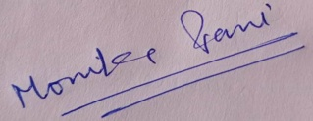
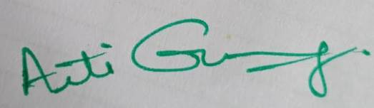
(Ms. Monika Guglani) (Ms. Arti Garg)
Coordinator,IQAC Chairperson,IQAC
INDIRA GANDHI (PG) MAHAVIDYALAYA, KAITHAL
INTERNAL QUALITY ASSURANCE CELL (IQAC)
Minutes of the meeting
(2019-2020)
2nd Meeting of IQAC held on July, 22, 2019, Monday; 2:30p.m. in the office of the Principal. The following members attended the meeting.
Sr.No. | Name of the Member | Designation | Status  (present/absent)
Sr.No. | Name of the Member | Designation | Status  (present/absent)
1 | Ms. Arti Garg | Chairperson IQAC | Present
2 | Ms. Monika Guglani | Coordinator IQAC | Present
3 | Ms. Seema Suneja | Teacher | Present
4 | Ms. Priyanka Bindlish | Teacher | Present
5 | Ms. Arti Chawla | Teacher | Present
6 | Ms. Jyoti Seth | Teacher | Present
7 | Ms. Nisha Mittal | Teacher | Present
8 | Mr. Amaranth Goel | Administration | Present
9 | Mr. Ram Bahadur Khurania | Management Representative | Present
10 | Mr. Subhash Sharma | Management Representative | Present
11 | Ms. Pooja Tiwari | Alumni Representative | Present
12 | Ms. Chhavi | Student Representative | Present

Following agenda was discussed in the meeting:
Agenda:
- To review and confirm the minutes of the last meeting.
- To prepare the academic calendar for the session 2019-2020.
- To discuss incentives for needy and meritorious students in academics, cultural and sports activities.
- To discuss about day to day working of the college.
- To make proposal for books/ journals/ periodicals.
- To promote students’ centric activities.
Resolution/Suggestions:
- The minutes of the last meeting were reviewed & passed by the co-ordinator and IQAC members.
- Academic calendar should be revised by IQAC members. Additional activities (co-curricular/academic) should be taken into account.
- Needy + meritorious students are given full fee concession and books are also provided through Book-Bank. Separate arrangement is made in the library for handicapped and disabled students.
- Work-load & Time-Table of all departments be maintained.
- Staff members are to extend their research activities by investing more time in library and by indulging in research activities.
- Student centric activities like group discussions, English speaking classes, seminars, tutorials should be arranged.

The meeting ended with thanks to the chair.
Submitted for approval of minutes. Seen and approved

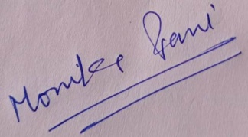
(Ms. Monika Guglani) (Ms. Arti Garg)
Coordinator,IQAC Chairperson,IQAC
INDIRA GANDHI (PG) MAHAVIDYALAYA, KAITHAL
INTERNAL QUALITY ASSURANCE CELL (IQAC)
Minutes of the meeting
(2019-2020)
3rd Meeting of IQAC held on Nov, 18, 2019, Monday; 2:30p.m in the office of the Principal. The following members attended the meeting.
Sr.No. | Name of the Member | Designation | Status  (present/absent)
1 | Ms. Arti Garg | Chairperson IQAC | Present
2 | Ms. Monika Guglani | Coordinator IQAC | Present
3 | Ms. Seema Suneja | Teacher | Present
4 | Ms. Priyanka Bindlish | Teacher | Present
5 | Ms. Arti Chawla | Teacher | Present
6 | Ms. Jyoti Seth | Teacher | Present
7 | Ms. Nisha Mittal | Teacher | Present
8 | Mr. Amaranth Goel | Administration | Present
9 | Mr. Ram Bahadur Khurania | Management Representative | Present
10 | Mr. Subhash Sharma | Management Representative | Present
11 | Ms. Pooja Tiwari | Alumni Representative | Present
12 | Ms. Chhavi | Student Representative | Present

Following agenda was discussed in the meeting:
Agenda:
- To take a review of department wise results.
- To discuss departmental activities (academic & co-curricular).
- To initiate various activities through different cells (cultural, sports etc.)
- To discuss about the submission of proposal for various seminars.
Resolutions/Suggestions:
- Extra classes will be arranged for those who took part in different cultural, sports and other co-curricular activities.
- Various departments are to arrange different activities to increase the interest of the students and to make them better understand the concepts.
- Various cells in the college (Women-cell, Red ribbon cell etc) are also to take some efforts to initiate various activities to improve skills in students.
- Inter-Zonal youth festival, State Level Ratnawali festival and also of sports, NSS, Cultural, Legal Literal Cell, Women Cell etc.
The meeting ended with thanks to the chair.
Submitted for approval of minutes. Seen and approved

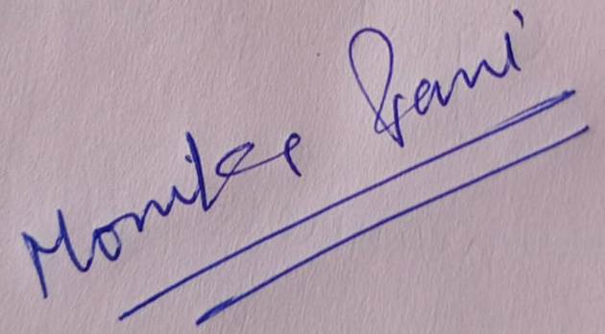
(Ms. Monika Guglani) (Ms. Arti Garg)
Co-ordinator, IQAC Chairperson ,IQAC

INDIRA GANDHI (PG) MAHAVIDYALAYA, KAITHAL
INTERNAL QUALITY ASSURANCE CELL (IQAC)
Minutes of the meeting
(2019-2020)
4th Meeting of IQAC held on March, 12, 2020, Monday; 2:30p.m in the office of the Principal. The following members attended the meeting.
Sr.No. | Name of the Member | Designation | Status  (present/absent)
Sr.No. | Name of the Member | Designation | Status  (present/absent)
1 | Ms. Arti Garg | Chairperson IQAC | Present
2 | Ms. Monika Guglani | Coordinator IQAC | Present
3 | Ms. Seema Suneja | Teacher | Present
4 | Ms. Priyanka Bindlish | Teacher | Present
5 | Ms. Arti Chawla | Teacher | Present
6 | Ms. Jyoti Seth | Teacher | Present
7 | Ms. Nisha Mittal | Teacher | Present
8 | Mr. Amaranth Goel | Administration | Present
9 | Mr. Ram Bahadur Khurania | Management Representative | Present
10 | Mr. Subhash Sharma | Management Representative | Present
11 | Ms. Pooja Tiwari | Alumni Representative | Present
12 | Ms. Chhavi | Student Representative | Present

Following agenda was discussed in the meeting:
Agenda:
- To review the agenda of the last meeting.
- To propose requirements of infrastructure for the session 2020-2021.
- To discuss about day to day working of the college.
- To promote and advertise the college achievements.
- To discuss the arrangement of online classes to complete the pending syllabus via Whatsapp, Google meet and other online modes.
- To initiate some steps raising awareness among students about wide spreading covid-19.
Resolution/Suggestions:
- The agenda of the last meeting was reviewed by the co-ordinator and the members of the IQAC.
- Agenda was maintained to discuss the day to day working of the college.
- Department wise results/achievements of the students are appreciated. Students having university positions are honoured.
- Online classes will be taken by staff-members and the revised schedule will also be maintained.
- Some measure would be taken to raise awareness among students like hanging banners, lectures etc.

The meeting ended with thanks to the chair.
Submitted for approval of minutes. Seen and approved

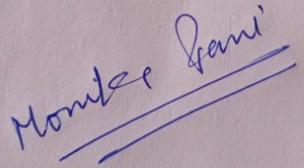
(Ms. Monika Guglani) (Ms. Arti Garg)
Co-ordinator ,IQAC Chairperson ,IQAC

