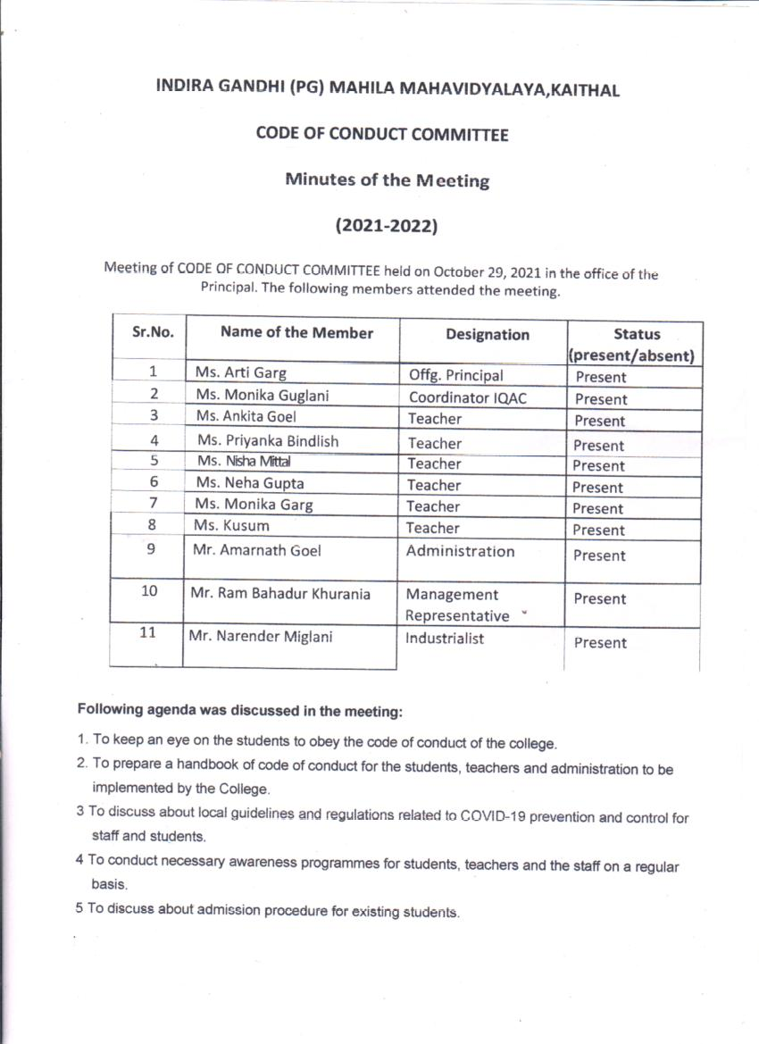
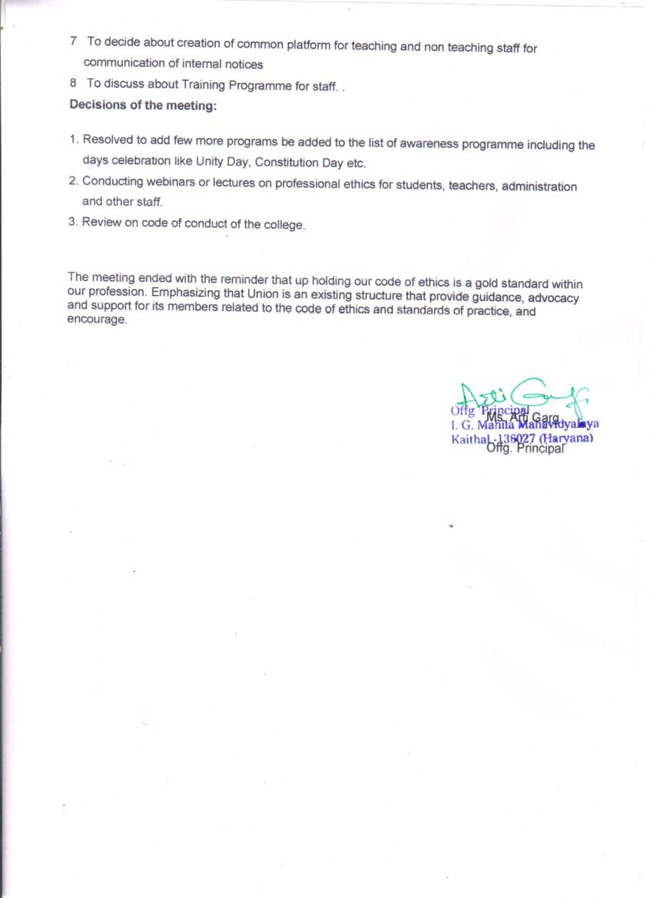

THE CODE OF CONDUCT FOR STUDENTS HAVE BEEN CLASSIFIED AS
A) COC IN COLLEGE PREMISES
B) COC IN LIBRARY
C) COC IN CLASSROOMS AND PRACTICAL LABS
D) COC DURING EXAMINATIONS

A) IN COLLEGE PREMISES
1)Students are required to bring their Identity card when they enter the college premises and produce it as and when asked for. In case the identity card has been lost/misplaced and not traceable , students are required to get the duplicate I-CARD made . Only bonafide students will be allowed to enter the college premises on producing their I- card.
2) Students are required to be properly attired and groomed in keeping with the dignity and decorum of the educational institutional culture and values.
3) Students are required to communicate in a decent and acceptable tone and language with their mentors, non- teaching and teaching staff. While in the company of peers, use of foul language and shouting and screaming in corridors is to be strictly prohibited. Students should focus their energies in constructive manner to learn , develop and enhance skills, competencies, Attitudes and values. It is to be noted that violent behavior and reckless yelling will be viewed as a serious case of misconduct hence students are advised to remain calm , maintain their Composure and refrain from contributing to the already existing noise pollution.
4) Mobile phones are strictly banned for the students inside the college premises and if any student is caught with mobile phone then strict action is taken against the student.
5) Students are required to enter and leave the college premises in a peaceful manner and avoid Overcrowding or group gathering at all times. Students are advised to maintain queue discipline as this will help facilitate easy entry and exit and help control student traffic efficiently .
6) Students are advised to actively participate in co-curricular, extra–curricular activities for their holistic development. Students interested in sport activities, curricular and extra- curricular activities are required to read the details displayed on the notice board and register to participate.
7) Student are advised to behave in a decent manner while in college premises as the entire premises is under CCTV surveillance .
8) The college has constituted an Anti-ragging cell as per the directives of the University. Ragging is a serious offence attracting disciplinary action.
9) At the time of admission, students are required to provide their correct current address, contact no (mobile ) and their email id so that the student data base can be updated. Any subsequent change of address or contact details are required to be communicated.
10) Student are required to maintain peaceful silence as they take the stairs and move towards their classrooms without creating any disturbance . Contribute and help maintain the positive conducive learning atmosphere of the college

B) IN LIBRARY
1)Students are required to register themselves at the Entrance desk .
2)Students are required to maintain silence in the library. No talking/ discussion is allowed .
3)Students are required to comply with all the rules and regulations and follow the instructions given by the librarian /library staff from time to time.
4) Students are advised to take good care of books issued . Handle with care and return them in a good condition. Do not mutilate the book or tear away pages from the book.

C) IN CLASSROOM/ PRACTICAL LABS –
1)Students are required to follow the class timetable and attend lectures/ practicals as per the time table. Students are required to be present in the classroom /labs on time for the lectures/ practicals.
2) Students have the right to learn without interference from others. Interruption, disruptions in class inhibits, prevents and reduces the efficacy of teaching – learning . It is the duty of every student to ensure that the conducive atmosphere for teaching- learning is maintained in the classroom. Some example of highly objectionable inappropriate behavior are- activities like using cell phones when the class is in progress, reading unrelated material, talking loudly so as to disturb the teacher and the class, entering the classroom late , passing offensive remark or comment on fellow students . Such notorious and disgraceful activities are strongly condemned and discouraged.
3)Students must note the minimum attendance required as per the University Ordinance and ensure adequate attendance during the academic year. In case of extenuating circumstances like illness requiring hospitalisation, the student is required to explain his/her absence in writing with adequate proof of hospitalisation and the competent authority(Principal) may condone her absence for the said period . The Principal at his/her discretion may decide “ what constitutes extraordinary or extenuating circumstances”
4)Students are expected to submit all assignments and get their projects certified by the Teacher-in –charge .
5) Student are expected to carefully listen and follow the instructions given by the teacher- in charge while performing practicals and handling chemicals, acids and other inflammable / hazardous solutions. It is the duty of the student to know the safety procedure and follow the safety norms.
6) Students must wear the lab- coat for performing the experiment in the lab.
7) In the classroom, students are required to actively participate in discussions on topics of academic interest and attend all lectures.
8) Save electricity by switching off fans and tubelights when not in use. While exiting the classroom, switch off all the fans and tubelights and conserve electricity.
9) Protect all college property from damage. No scribbling on walls, carving on benches or destroying college furniture. Handle test tubes,glass and other fragile lab equipments , chemicals and acids safely and with care so as to minimize damages due to mishandling/ breakage .
10) Discipline is to be maintained in the classroom in the absence of teacher in classroom .Do not disturb the other classes .
11) Computers made available in computer labs are to be used for academic purposes only.

D) EXAMINATIONS
1) The college has adopted Zero tolerance towards unfair means and cheating in the examination.
2) The college strongly advocates academic honesty in examination and views academic dishonesty seriously.
3) Students are required to refer to the examination time table and take the examination as per the schedule.
4) Students are required to follow the instructions given by the supervisors / senior supervisors during the examination.

THE CODE OF CONDUCT FOR TEACHERS
INCLUDES NORMS DURING TEACHING, EVALUATION AND
INTERACTIONS WITH STUDENTS , AUTHORITIES, COLLEAGUES AND SENIORS.
1) Wear I-card at all times when present in the college.
2) Be punctual. Report on time for work – engaging lectures and practicals and for supervision during exams. Engage the lectures and practicals as per the individual timetable allotted
3) Record presence by signing attendance register.
4) Complete all teaching work allotted within given time duration. All evaluation and exam related work to be completed within the stipulated time.
5) The teachers should deal justly and impartially with students regardless of their opinion, religion, caste, gender, political, economic, social and physical characteristics.
6) Encourage students to improve their attainments, develop their personalities and at the same time contribute to community welfare.
7) Teacher should make themselves available to the students even beyond their class hours and help and guide students without any remuneration or reward.
8) Teachers should treat their colleagues and non- teaching staff respectfully and render assistance for professional betterment in the same manner as they themselves wish to be treated.
9) Teachers should refrain from lodging unsubstantiated allegations against colleagues to higher authorities.
10) Teachers should co-operate in the formulation of policies of the institution and discharge responsibilities which such offices may demand without hampering their academic pursuits.
11) Teachers should give prior notice, information or application to the office for any kind of emergency.
12) Teachers should recognize that education is a public service and strive to keep the public informed of the educational programs which are being provided.
13) Teachers should not obstruct staff of the institution from performing their lawful duties and indulging in any sort of agitation to coerce or embarrass institution authorities.
14) Teachers should not misappropriate an institutions property, commit acts of thefts, fraud or embezzlement of funds.

CODE OF CONDUCT FOR NON- TEACHING STAFF
1) Report on time for work. Be punctual and discharge duties allotted promptly.
2) Behave decently in keeping with the discipline and decorum of the institution
3) Consumption of alcohol, intoxicants, tobacco, smoking is strictly prohibited while on duty.
4) Know the service conditions, duties and responsibilities , rules and regulations regarding leave, salary and other related matters
5) Follow the organizational hierarchy and protocol .

Expected Outcomes
1) The constitution of code of conduct committee, professional ethics following the guidelines regarding maintenance of Discipline in the college, prohibition of and punishment of Ragging and sexual harassment, Human Rights, examination, classes, Institutional values, other support services.
2) The College has institutionalized mechanisms to sensitize all stakeholders regarding professional ethics, human values, gender equity and environment sustainability through its interdisciplinary approach and various academic and extracurricular endeavors.
3)In the classroom, all teachers ensure an inclusive learning space and adopt an interdisciplinary approach towards various socio-cultural issues. Additionally, the college offers a paper on Environmental Sciences and consciousness for students of all the courses. This in addition to orientation programmes on Ethics and Values helps in imparting value-based education to generate awareness.

Awareness programs on Professional ethics

I.G.(P.G.)M.M.V.KAITHAL organizes professional ethics programs for students, teachers and staff separately. Students and teachers attend an orientation program in the college organized by COCC. Hawan ceremony was organized for the beginning of session.
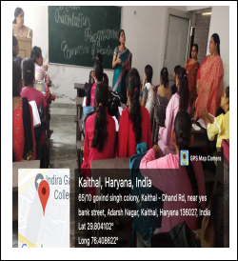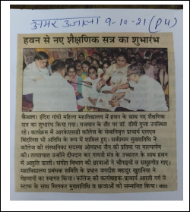

Physical and Sports activities including Yoga was coordinated by Sports in-charge almost every day. Sports activity comprises of Football, Volleyball, Badminton, Table Tennis, Running, Free Hand Exercise, Flexibility, Strength Exercise, Speed Training, Endurance Training, Kabaddi, Athletics,Judo,Multi-gym Training, Recreational Games etc.

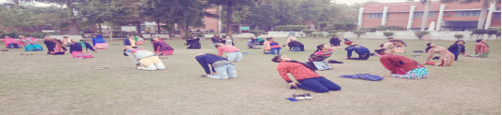

Our college organize Industrial and Educational trips for concerned departments time to time. Students visited mills, factories, banks, and Zoological park.
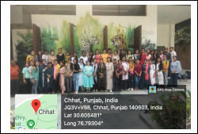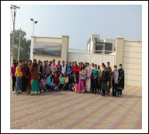

Our students participate in District level science exhibition organized by Government College every year.

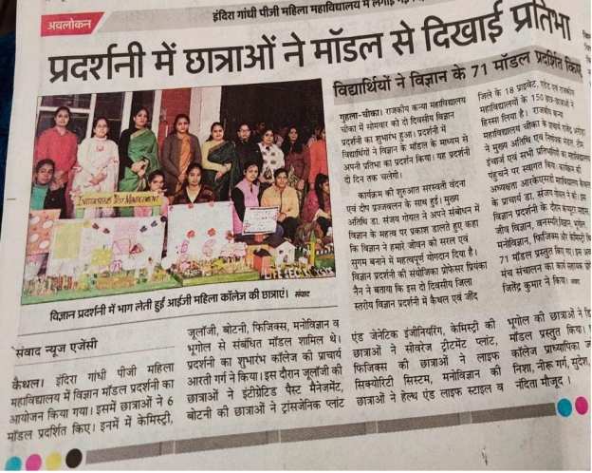
Students of psychology participate in various activities related to topic mental health to aware students, people and the staff regarding mental issues which they face during their life. Students of psychology also participated in an Exhibition on topic Mental Health.
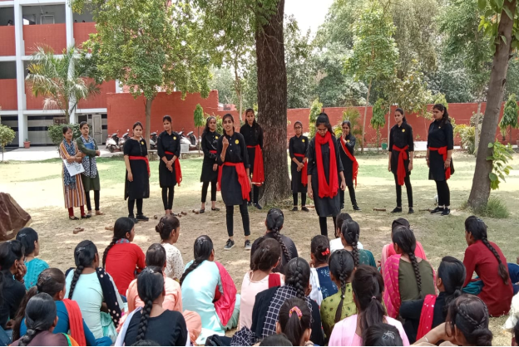

Career Guidance Cell of our College plays a very important role in the lives of all individuals as it helps in setting future goals and chooses careers. Career Guidance and Placement Cell organize seminars every year for students. 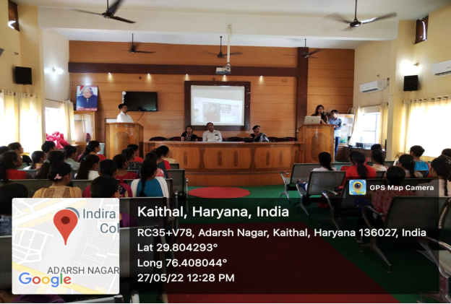

Banners depicting prohibition of Mobile Phones inside the College Campus are displayed at each Department and various other places of the college as well.
