Activities regarding Language, Communication and Life Skill
Sr. No. | Sub/ Deptt. | Competition/ Activity | Organized By | No. of Part. | Position | Picture
1 | Dept of Health and Physical Education | Art of Living(Meditation)  (24.02.2023) | IGMMV, Kaithal | All Lecturers & Students |  | 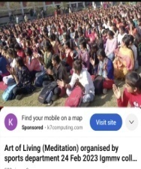
2 | Hindi Dept. | Talent Hunt  Speech & Poem Activity  01.10.2022 | IGMMV Kaithal | 8 | 1st Karamjeet(Speech),  1st Payal(Poem) | 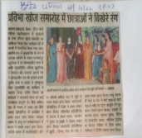
3 | English & Mass Communication | Workshop on Paper Reading (05.04.2023) | I.G.M.M.V. Kaithal | 40 | Students of BAMC | 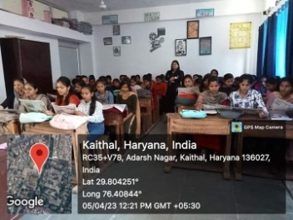
4 | Dept of Health and Physical Education | Health & Physical Awareness Camp(28.09.2023-29.03.2023) | IGMMV, Kaithal | All Lecturers & Students |  | 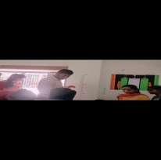  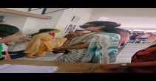  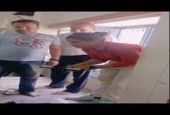
5 | English | Talent Show Poem Recitation (01.10.2022) | I.G.M.M.V. Kaithal | 5 | 1st Juhi,  2nd Mehak | 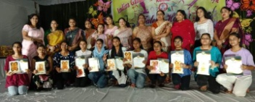
6 | English | Talent Show Declamation Competition (01.10.2022) | I.G.M.M.V. Kaithal | 7 | 1st Sachleen Preet Kaur,  2nd Renu | 