The institution sensitizes the students and the employees to the constitutional obligations about values, rights, duties and responsibilities and constantly works upon to nurture them as better citizens of the country through various curricular and extra-curricular activities. The college curriculum is framed with courses like Introduction to Constitution of India, Gandhian Economic Thought, Moral Philosophy, Practical Ethics, Value Education, to inculcate constitutional obligations among the students. The institute hoists the flag during national festivals and invites eminent persons to inspire students and staff by informing the qualities of freedom fighters and to emphasize the duties and responsibilities of citizens. The college establishes policies that reflect core values. Code of conduct is prepared for students and staff and everyone should obey the conduct rules. The institution encourages participation of students in Sports and Games and NSS at National level to strengthen nationwide bond and relation. Staff members participate in the national celebrations, Flag Day and take oaths for the cause of the nation. The institution takes many initiatives like conducting awareness campaigns, organizing orientation programmes, training programmes, seminars and workshops to sensitize the future leaders to inherit human values coping with the constitutional obligations. Ethical Values, rights, duties and responsibilities of citizens are some of the topics that are enlisted in Elocution/ Debates activities. The students have enthusiastically participated in various activities like seminar, conferences, expert talks, poster making competition, competition on various contemporary legal issues. Various departments, cells of the institution and NSS unit are actively involved in conducting several activities for inculcating values for being responsible citizens are given below:

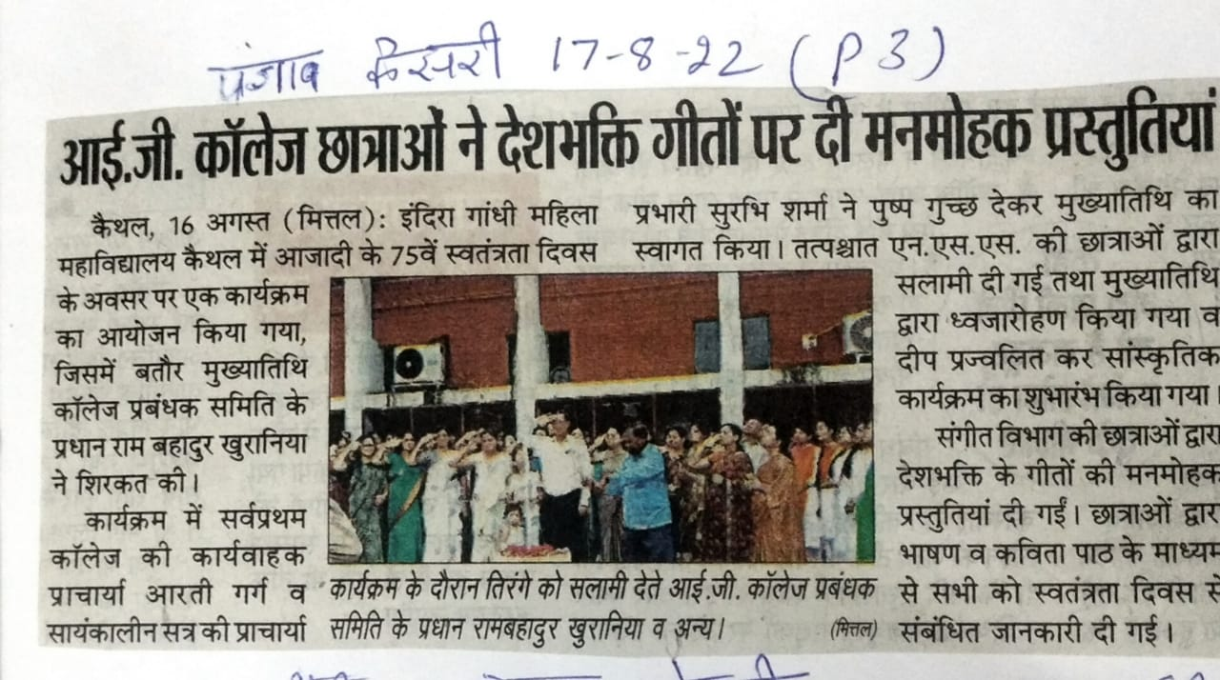  Independence Day Celebration | 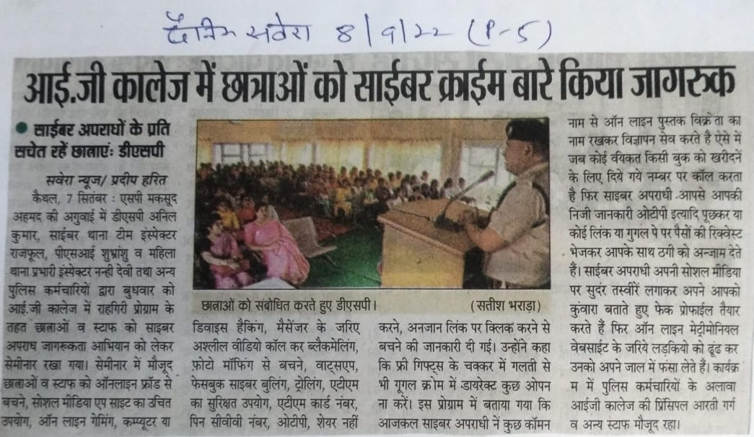  Cyber Crime Awareness
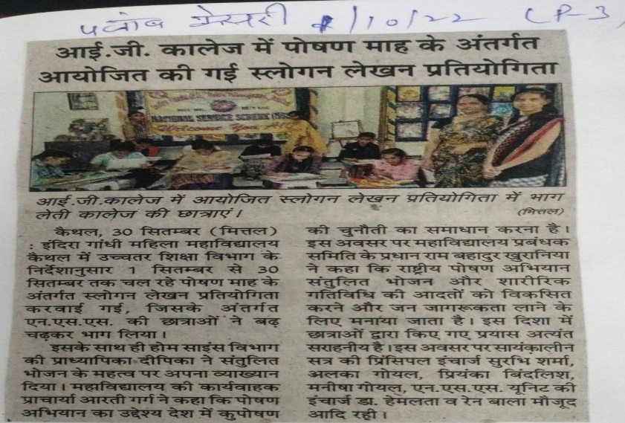  Awareness on Health and Hygiene (Balanced Diet) | 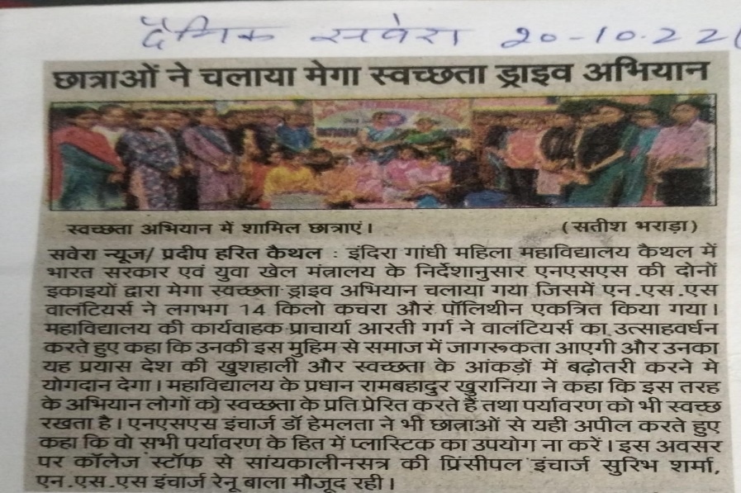Cleanliness Drive Campaign
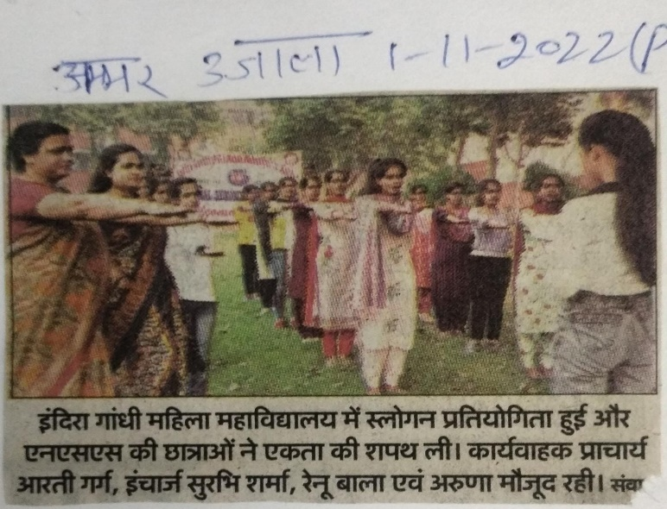  Pledge on Unity | 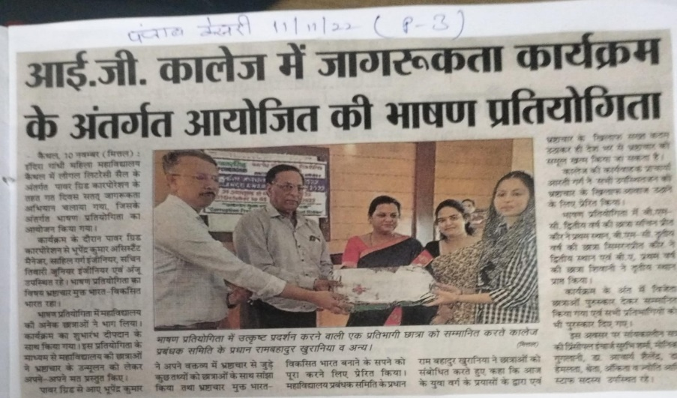  Declamation Competition on  Corruption Free India
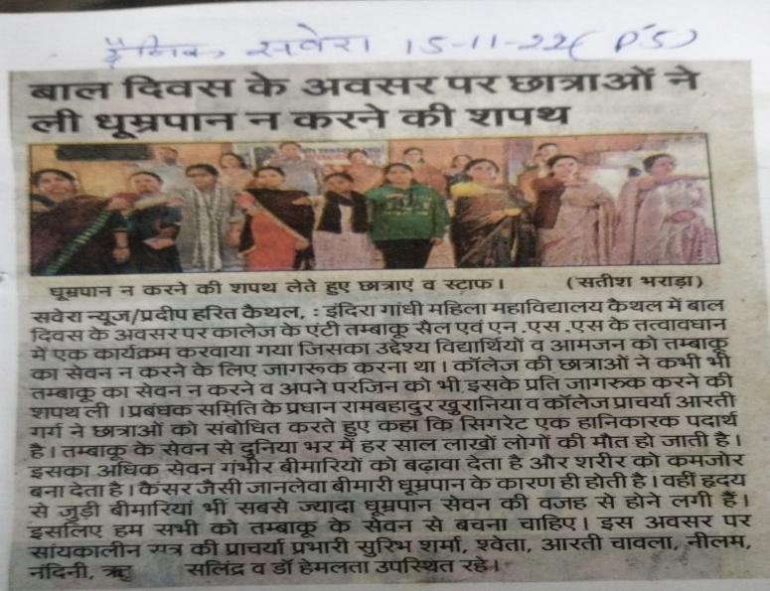  Pledge on no Tabacco Consumption | 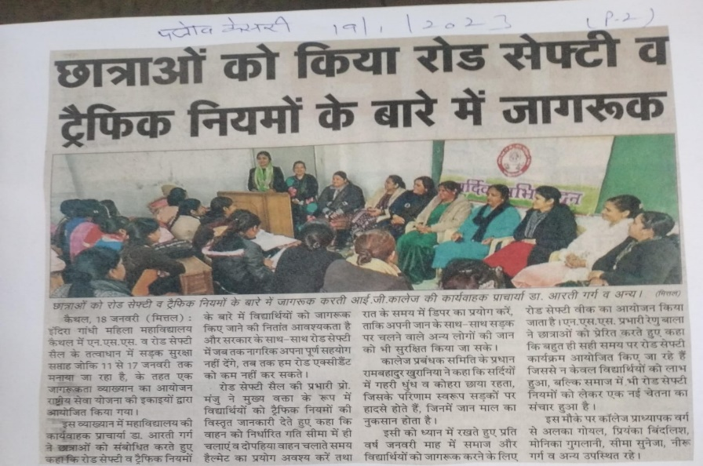  Awareness of Road Safety and  Traffic Rules
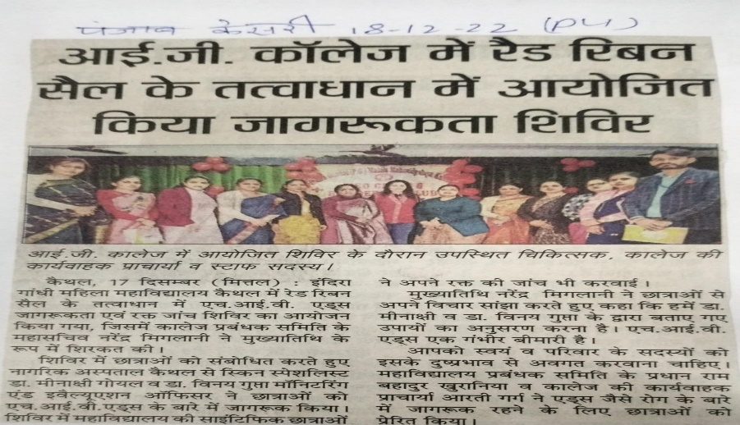  Awareness on HIV/AIDS | 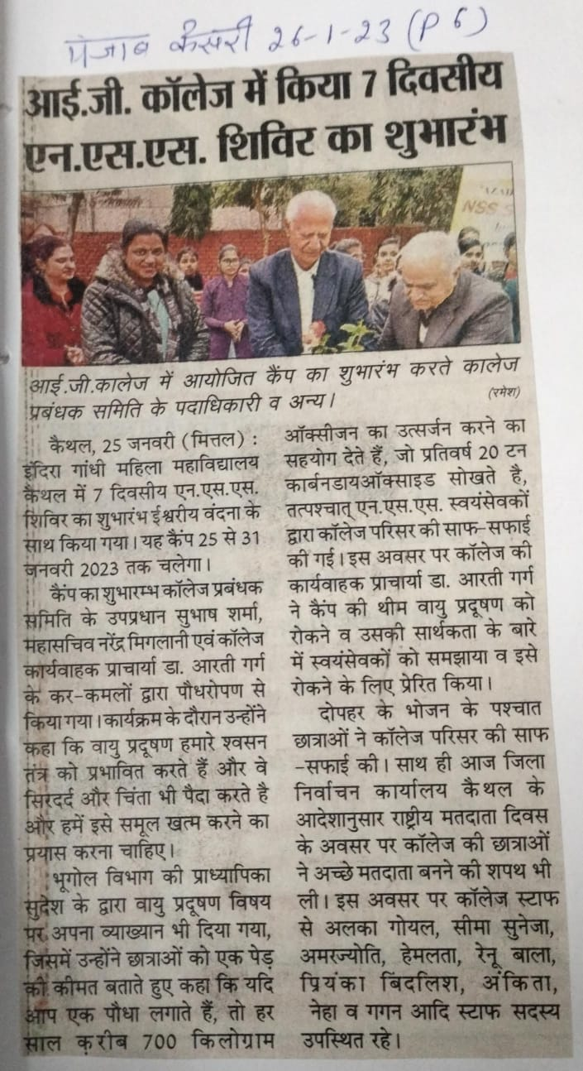  Awareness Camp to Control and  Remove Air Pollution
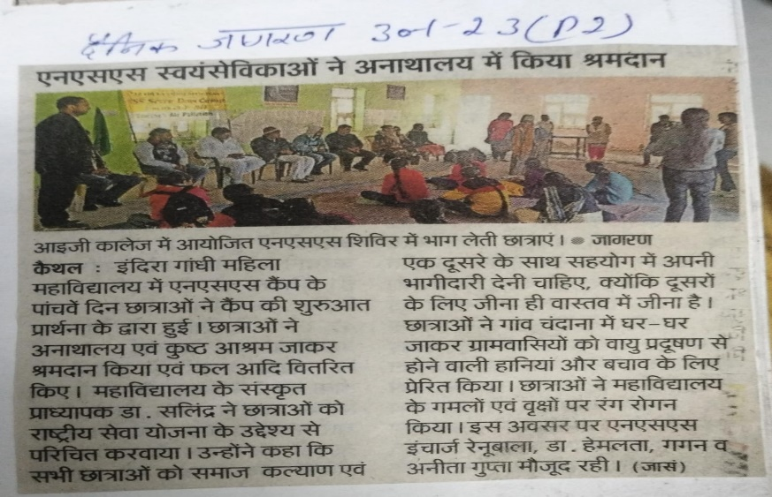  Donation in Orphanage | 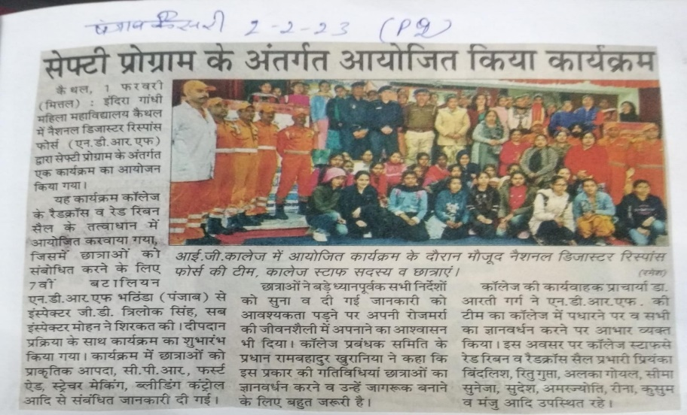  Awareness of Safety Program
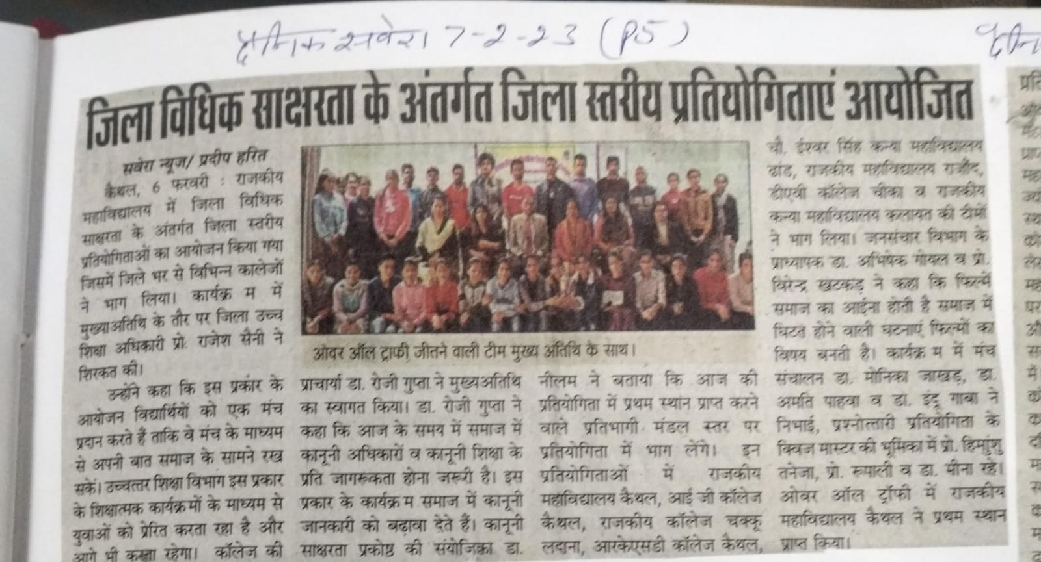  Competition on Awareness of Legal Rights and Legal Education in the Society | 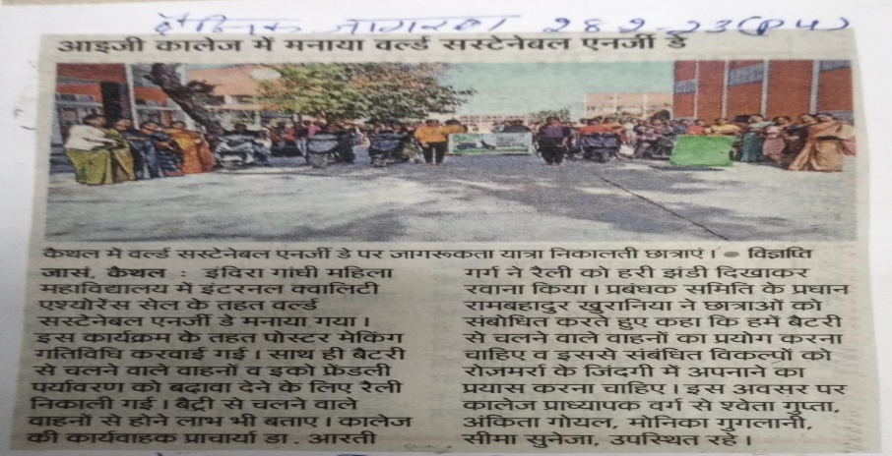  Rally on use of Battery Vehicles and  Eco-Friendly Environment
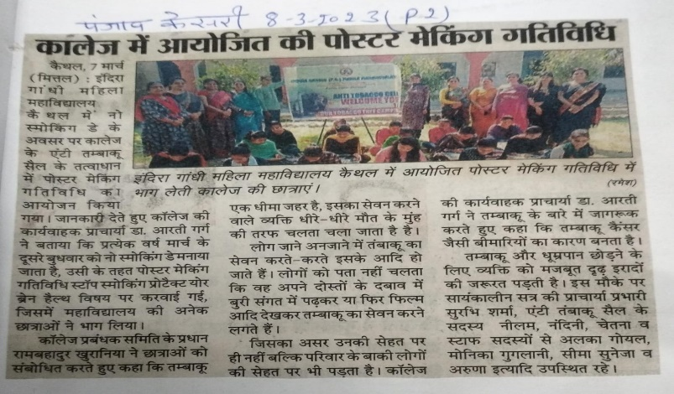  Poster Making Activity on Stop Smoking- Protect your Brain | 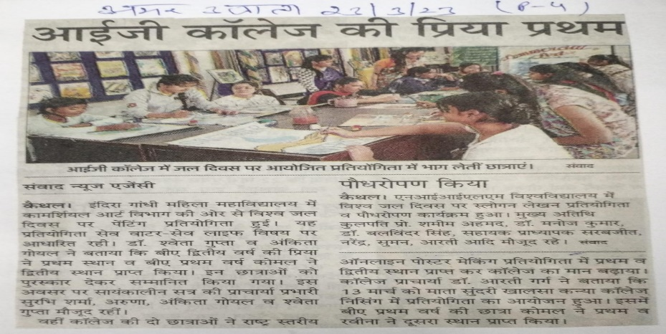  Poster Making Activity on  Save Water, Save Life
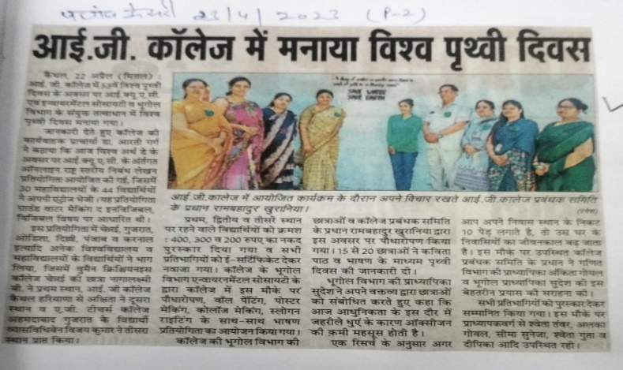  Essay Writing on Ground Water- Making the Invisible, Visible | 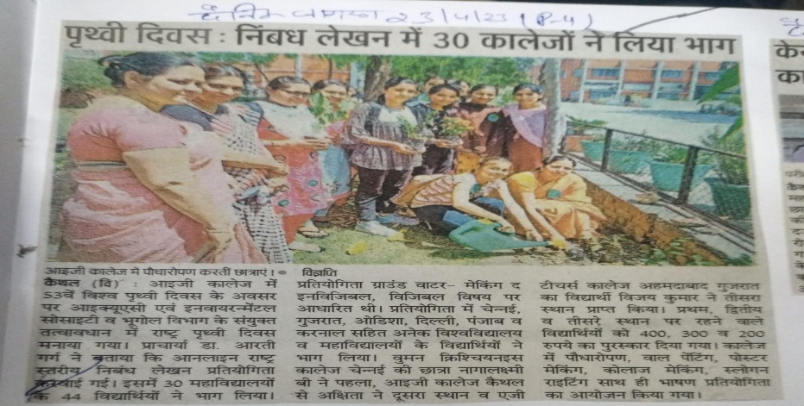  Tree Plantation by Students
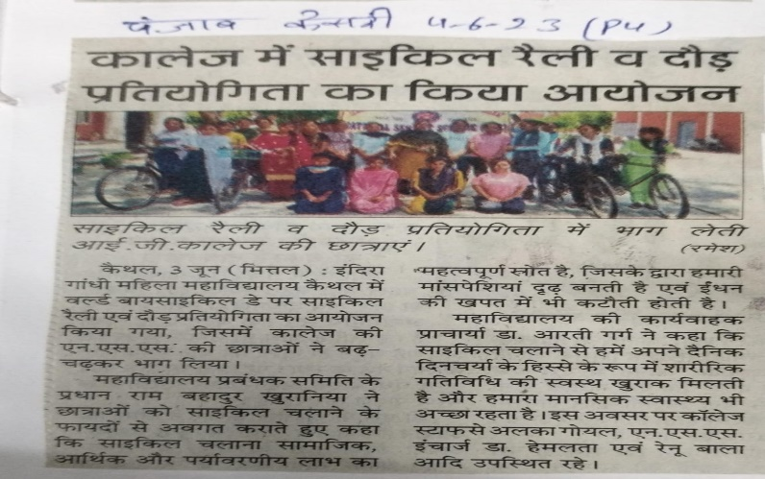  Rally on Cycling | 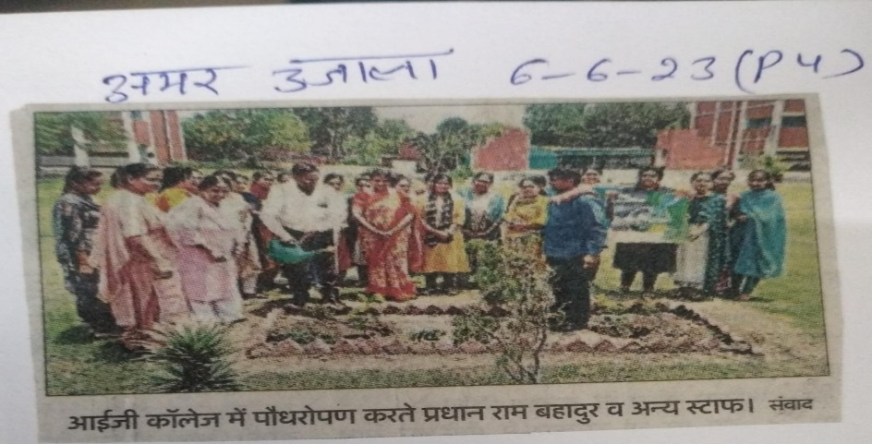  Tree Plantation on  World Environment Day

