Sr No. | Best award | Name of the student | Year(2022-23) | Document
1. | Best singer | Navjot | B.Com | 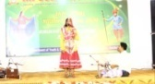
2. | Best Dancer | Komal | B.A | 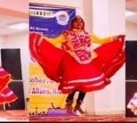
3. | Best Photographer | Sudesh | B.A.M.C | 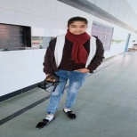
4. | Best Speaker (English) | Simranpreet Kaur | B.A.M.C | 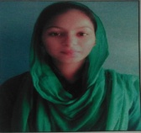
5. | Best Speaker (Hindi) | Sachleenpreet kaur | B.A.M.C | 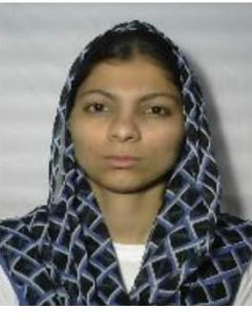
6. | Best Athlete | Sonali | B.A | 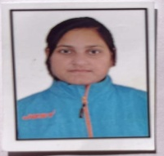
7. | Best NSS | Sudesh | B.A.M.C | 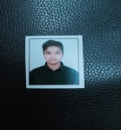
8. | Best artist | Priya | B.A | 