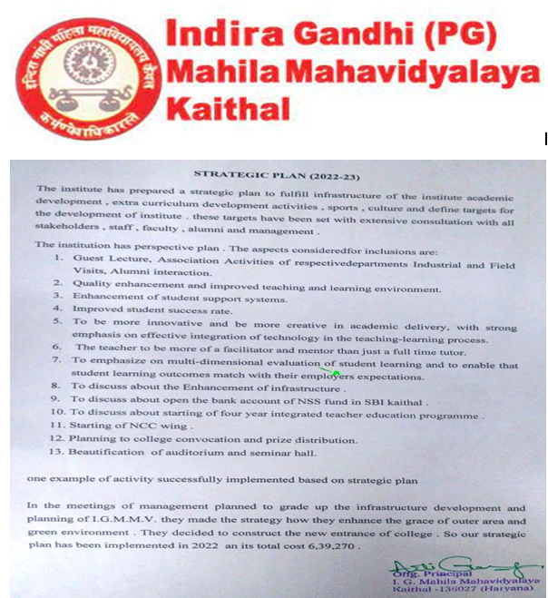

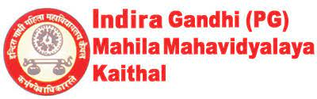
Teaching learning process | The college strictly adheres to the academic calendar of K.U.K. In the beginning of the session , orientation programmes are organized stream wise to familiarize the students with rules and regulations . Every year our students make us proud by grabbing positions in the university merit list. Remedial classes are arranged for the betterment of students by various departments. Preparation of Academic Calendar, Lesson Plan, Use of more ICT tools, Development of e-learning resources, enrichment of the curriculum through versatile techniques.
Good Governance | Monitoring and Implementing the Quality Management System, e- governance, code of conduct, Introduction of integrated 4 years course in BA/ B.Sc. B.Ed.
Student’s development and participation: | Students training and placement activities, Formation of student council, Participation in extracurricular activities, social and welfare activities, representation in committees and cell.
Human resource management | Teaching and non teaching staff awarded for their valuable contribution on independence day , teachers day and on other festivals etc. There is staff appraisal system for all teaching staff .Guest lectures are held for the development of the staff and Motivation for qualification improvement and research..Proper recruitment Policy , best possible work facilities and Deputation for seminars and workshops are also provided.
Alumni Interactions | Registration, Recognition of successful alumni, Exploring contributions.
Physical infrastructure | Infrastructure building development and modification, smart class rooms, More ICT enabled class rooms, Library infrastructure expansion and up gradation, Water and medical facility, Plantations, Green campus, Recycling through segregation of waste The college has well resourced library catering to the needs and interest of the students and faculty. Availability of books can be viewed through LAS system. The college campus has a CCTV security system , well equipped seminar halls , auditorium, dispensary, meditation room , departmental offices and laboratories .
Financial Management | Plans for emergency Fund, Periodic audit, Department wise budget planning.
Curriculum development | The institute strictly follows the Curriculum designed by Kurukshetra University and plans meticulously for its effective implementation. In the beginning of the semester, time-table and lesson plans are prepared. Efforts are made to introduce certificate courses keeping in view the changing scenario. Emphasis is laid on “Women Empowerment” and “Protection of Environment” by organizing various programmes frequently. The institute promotes use of ICT to make learning effective. Guest lectures, workshops and industrial visits are regularly organized. Feedback of the students is taken regularly and suggestions are incorporated which ensures an effective delivery of the curriculum.

